Write a program for Tic Tac Toe using python code

Aim :To implement the Tic-Tac-Toe game using Python.
Procedure:
Create a 3×3 game board.
Allow two players to enter their moves alternately.
Update the board after each move.
Check for a winning condition or draw.
Display the result.

Output:

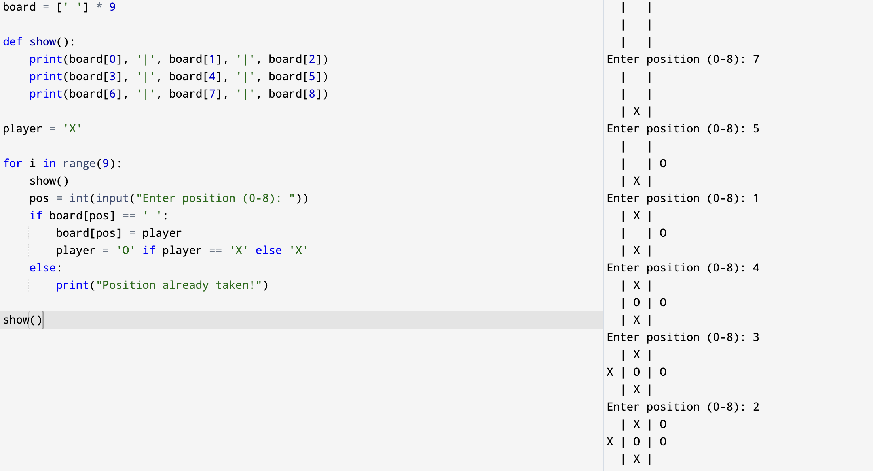

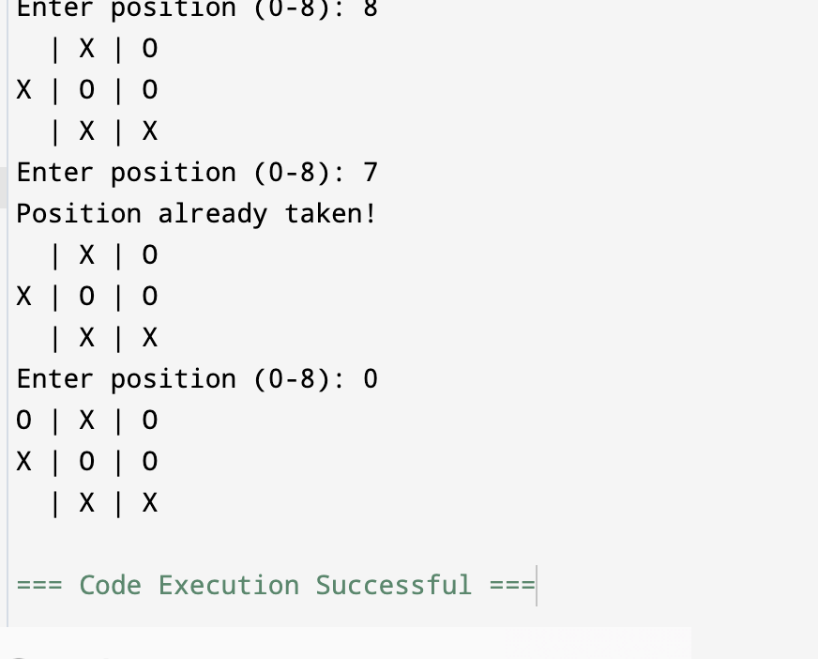

Result: Hence, Tic Tac Toe problem has been solved

